**XL602** – Excel 2016 Intermediate

# Table of Contents

**Module 1:** *Using Names*

* What is Name?
* The advantages of using Names
* Name for single cell
* Name for literal value
* Name for expression
* Name for multi-cells range
* Name Scoping, ambiguity and conflict resolution
* Modify Name
* Delete Name

**Module 2:** *Using Table Features*

* Creating a Table
* Delete Table
* Change Table Name
* Sorting a Table
* Filtering a Table
* Working with the Total Row
* Creating a Calculated Column
* Formatting a Table
* Referring to different parts of table

**Module 3:** *Working with Formatting*

* Applying Conditional Formatting
* Using Data Validation
* Entry guide
* Custom Error Message
* Creating and Using Custom Formats
* Using the Quick Analysis Tool
* Using Table for Validation
* Something to know about validation

**Module 4:** *Information Retrieval*

* Observation Techniques
* Basic Features – Filter and Sorting
* Using Functions and Formulas
* Using Pivot Table

**Module 5:** *Working with Charts*

* Creating Charts
* Changing the Chart Location and Size
* Changing the Chart Type
* Modifying Chart Elements
* Formatting Chart Elements
* Adding and Removing Data Series
* Applying a Chart Filter
* Printing Charts
* Creating and Using a Chart Template
* Sparkline

**Module 6:** *Protection*

* Protecting Workbooks and Worksheets
* Protecting a Workbook
* Protecting a Worksheet
* Allowing Users to Edit Ranges

**Module 7:** *Using Styles and Templates*

* Working with Cell Styles
* Using Templates

# Exercises

|  |  |
| --- | --- |
| **1.1** | ***Housing Loan*** |
| **1.2** | ***Payroll*** |
| **1.3** | ***Employee*** |
| **1.4** | ***Naming conflict resolution*** |
| **1.5** | ***Modify Name*** |
| **1.6** | ***Delete Name*** |
| **2.1** | ***Create Table*** |
| **2.2** | ***Rename Table*** |
| **2.3** | ***Use Table Data in validation (Part-1)*** |
| **2.4** | ***Use Table Data in validation (Part-2)*** |
| **3.1** | ***Various types of validation*** |
| **3.2** | ***Adding calculated column*** |
| **3.3** | ***Using Data Bar*** |
| **3.4** | ***Detect Duplicate data*** |
| **4.1** | ***VLookup (Exact Match)*** |
| **4.2** | ***VLookup (Approximate Match)*** |
| **4.3** | ***Create PivotTable*** |
| **4.4** | ***View fields and data*** |
| **4.5** | ***Filter a field*** |
| **4.6** | ***Create PivotChart*** |
| **5.1** | ***Add Chart*** |
| **5.2** | ***Move Chart*** |
| **5.3** | ***Create multiple Data Series chart*** |
| **5.4** | ***Remove Data Series*** |
| **5.5** | ***Sparkline*** |
| **6.1** | ***Protect the workbook structure*** |
| **6.2** | ***Protecting a Workbook*** |
| **6.3** | ***Protecting a Worksheet*** |
| **6.4** | ***Allowing Users to Edit Ranges*** |
| **7.1** | ***Apply a cell style*** |
| **7.2** | ***Create a custom cell style*** |
| **7.3** | ***Create a cell style by modifying an existing cell style*** |
| **7.4** | ***Remove a cell style from data*** |
| **7.5** | ***Merging Style*** |
| **7.6** | ***Delete a predefined or custom cell style*** |
| **7.7** | ***Save a workbook as a template*** |
| **7.8** | ***Create a workbook based on the template*** |

# **Module 1:** *Using Names*

What is Name?

In Excel, you can create names that refer to a single cell, a group of cells on the worksheet, a specific value, or a formula. After you define Excel names, you can use the names in a formula, instead of using a constant value or cell references.

An Excel name can't contain space characters, and there are other rules to follow when you're creating a name.

The first character of a name must be a

* letter
* underscore (_)
* backslash (\).

Subsequence characters in the name can be

* letters
* numbers
* periods
* underscore characters

Spaces are not allowed as part of a name.

Names can contain uppercase and lowercase letters. But Excel does not distinguish between them. For example, North and NORTH are treated as the same name.

Names cannot be the same as a cell reference, such as A2, A$35 or R2D2.

You cannot use **C**, **c**, **R** or **r** as a defined name -- they are used as selection shortcuts.

To create names:

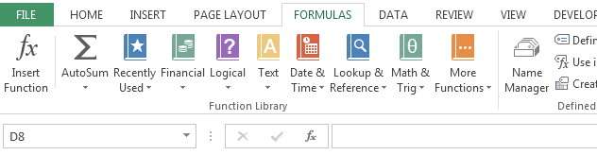

**Name Manager**

**Name Box**

The advantages of using Names

There are few advantages when using names:

1. Can make the formulas easier to understand
2. Address independent. Make workbook maintenance easier
3. Single point of reference. Any future changes impact will be minimized.
4. The name will be utilized by other aspects of excel and will make those aspects better, for instance better scenarios summary and clearer solver constraints.

Name for single cell

## **EX1.1: *Housing Loan***

In this exercise you will learn how to use name to represent single cell.

1. Insert a new worksheet
2. Change the worksheet name to **Housing Loan**.



1. Prepare the worksheet as below:

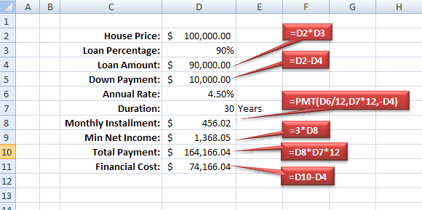

1. Copy worksheet **Housing Loan**, and rename the copy as **Housing Loan (Use Name)**.



1. Switch to worksheet **Housing Loan (Use Name)**.
2. Select the **Formulas** Tab and then click **Name Manager** button.

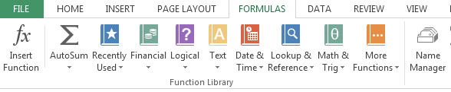

1. You should able to see the following dialog box, click the **New…** button

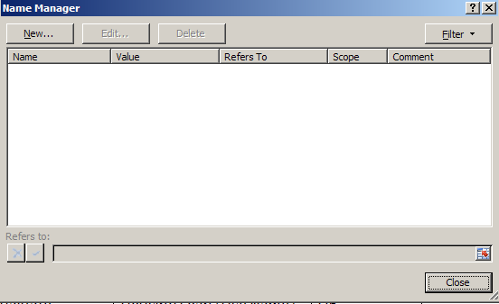

1. Create the following names for the active worksheet.

|  |  |  |
| --- | --- | --- |
| **Name** | **Scope** | **Reference** |
| HousePrice | Housing Loan (Use Name) | D2 |
| LoanPercentage | Housing Loan (Use Name) | D3 |
| LoanAmount | Housing Loan (Use Name) | D4 |
| DownPayment | Housing Loan (Use Name) | D5 |
| AnnualRate | Housing Loan (Use Name) | D6 |
| DurationInYears | Housing Loan (Use Name) | D7 |
| MonthlyInstallment | Housing Loan (Use Name) | D8 |
| MinNetIncome | Housing Loan (Use Name) | D9 |
| TotalPayment | Housing Loan (Use Name) | D10 |
| FinancialCost | Housing Loan (Use Name) | D11 |

1. Change the cells value to the following:

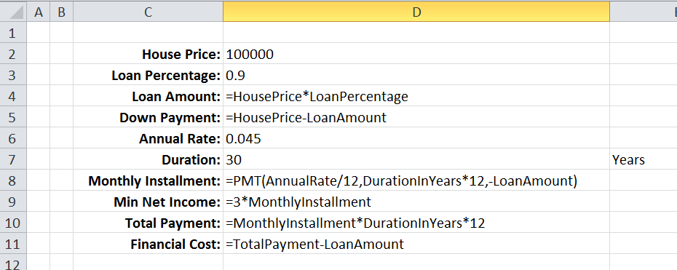

Name for literal value and expression

## **EX1.2: *Payroll***

In this exercise you will learn how to use name to represent literal value and expression.

Assuming you contribute 11% of your salary to EPF account, and your employer contributes 1% more.

1. Insert a new worksheet
2. Change the worksheet name to **Payroll**.
3. Declare a local name called **BasicSalary** refers to cell D2
4. The worksheet will be as below:

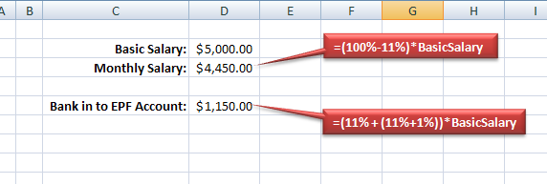

1. Declare the following names for the active worksheet:

|  |  |  |
| --- | --- | --- |
| **Name** | **Scope** | **Reference** |
| EPFEmployee | Workbook | =11% |
| EPFEmployer | Payroll | =EPFEmployee+1% |

1. Change the worksheet by using newly created names. Now the worksheet show be as below:

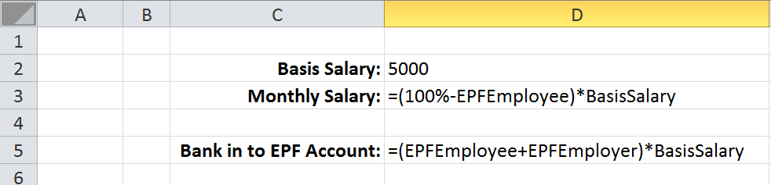

Name for multi-cells range

## **EX1.3: *Employee***

In this exercise you will learn more how to apply name to multi cells range.

1. Insert a new worksheet
2. Change the worksheet name to **Empoyee**.
3. Prepare the worksheet as below:

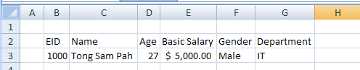

1. Create a new worksheet, and give it a name **Lists**.
2. In the Lists worksheet
   1. Enter the data as shown
   2. Select cell B3:B7
   3. Click on the name box and type **Departments** followed by **Enter**.

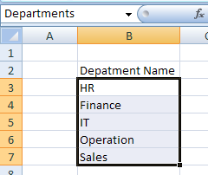

You just created a workbook scope name called **Departments** represents range B3:B7. While in the Lists worksheet, click the name box drop down, you should be able to see the name from the drop down list.

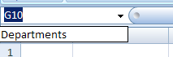

1. Switch to Employee worksheet, click cell G3

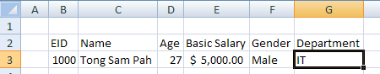

1. Select tab **Data** and click **Data Validation** button.

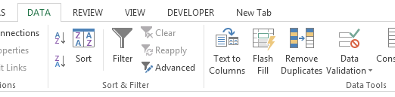

1. In the dialog box, select Allow: **List** option

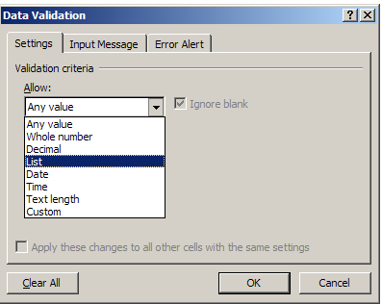

1. Key in the source as below:

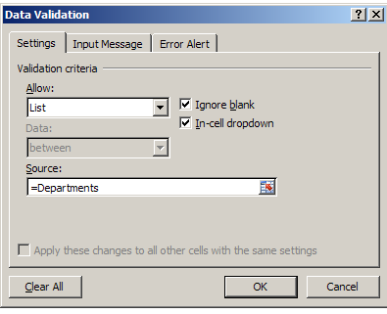

1. Select the **Input Message** tab from the dialog box. Key in the input message a below:

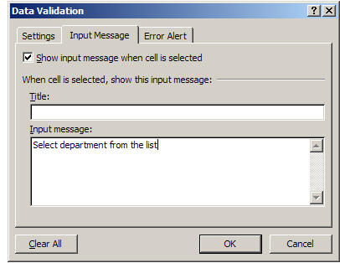

1. Select **Error Alert** tab from the dialog box. Key in the Error message as below:

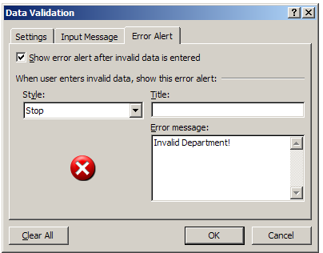

1. Press **OK** to end the dialog box.
2. Back to worksheet, click on dropdown button:

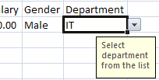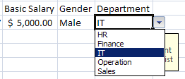

Name Scoping, ambiguity and conflict resolution

Name scope can be either

* Worksheet
* Workbook

The name under worksheet scope only can be referred within the worksheet without qualifier

The name under workbook scope can be referred within the entire workbook without qualifier

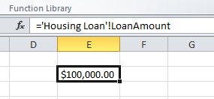

**Worksheet Qualifier**

**Ground rule:** Name must be unique under the same scope.

For example, you can’t declare same names under same worksheet.

However, you can declare one name under workbook scope, and at the same time the same name under worksheet scope.

If ambiguity occurs, worksheet scope will shadow workbook scope. But this rule can be overwritten by using qualifier.

## **EX1.4: *Naming conflict resolution***

In this exercise you will learn how naming ambiguously is resolved.

1. Create a name **X** with workbook scope with value 100.

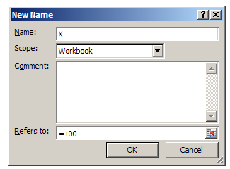

1. Create a local name **X** under worksheet **Payroll** with value 200.

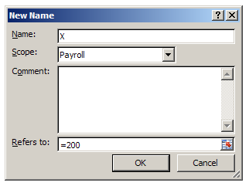

1. Under cell A1 of worksheet Payroll, type “=X”

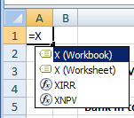

1. Press **ESC** to cancel the entry

Modify Name

The name and it reference can be changed only by using name manager. But the name scope can’t be modified. The only way to change the scope is delete it and create again with the new scope.

## **EX1.5: *Modify Name***

In this exercise, you will learn how to modify names

1. Run the **Name Manager**, select the workbook scope X, click **Edit...**

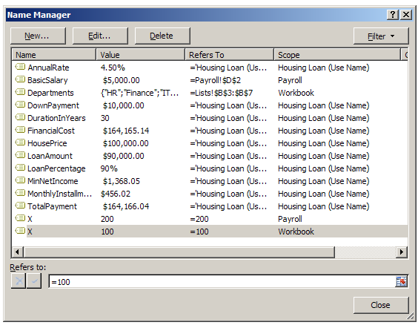

1. Change the value to 150, click OK.

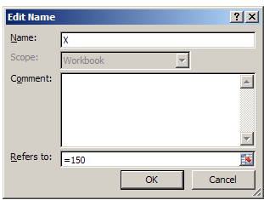

1. Select name **X** under the Payroll Scope. Select **Edit…**

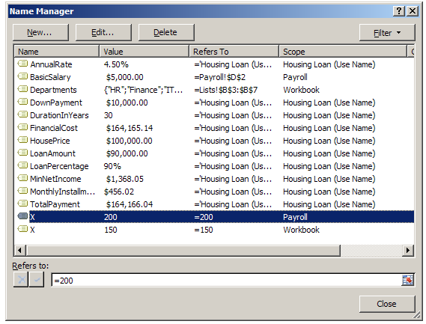

1. Change the name to **Y**.

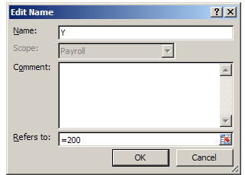

1. Discuss how to change the scope of name **X** to scope of **Housing Loan** worksheet?

Delete Name

Name can be deleted by using Name Manager.

## **EX1.6: *Delete Name***

In this exercise, you will learn how to delete names

1. Run **Name Manager**.
2. Select names **X** and **Y**. (Control Click for multiple select)

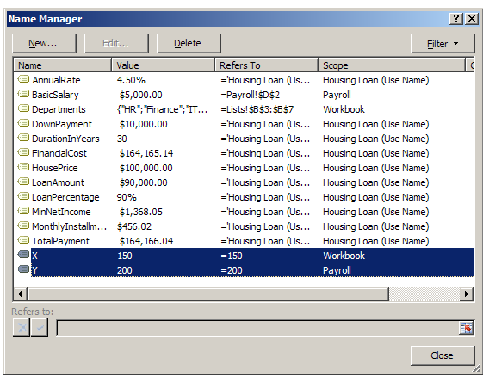

1. Press **Delete**.

# **Module 2:** *Using Table Features*

Tables began as lists in the menu before version 2007, but they've become more powerful in the Ribbon versions. Converting a data range into a table extends functionality, which you can then use to work more efficiently and effectively. Here's a look at why you should consider using a table instead of an ordinary data range.

Bear in mind that as handy as tables are, they don't accommodate all of Excel's features. For example, you can't use Excel's Subtotal feature with tables. When you need a feature that tables don't support, temporarily convert the table into a range.

Some main benefits of using Table advantages over name ranges:

1. Easy sorting and filtering
2. Quick formatting
3. Effortless data entry
4. Automatic nomenclature
5. Quick totals
6. Always visible headers
7. Formula autofill
8. Dynamic charts
9. One-click select
10. Can allow access to various parts of the table

Creating a Table

Select the data range, then from the **Home** tab select:

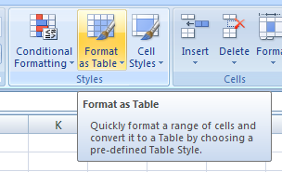Common practice is try not to format the cell before apply table. The existing cell format will disturb the table color scheme.

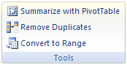Delete Table

1. Right-click the table, point to Table, and then click **Convert to Range**.
2. On the **Design** tab, in the **Tools** group, click **Convert to Range**.

Caution that after convert to range, although the table is removed, but the format still remain.

## **EX2.1: *Create Table***

In this exercise, you will learn how to create table

1. Switch to worksheet **Lists**.
2. Select range B2:B7

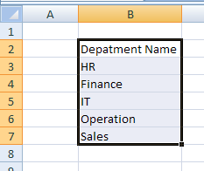

1. Select **Home** tab. Click **Format as Table** button. Select the table style you prefer.
2. Make sure that **My table has headers** in the dialog box is checked. Press **OK**.

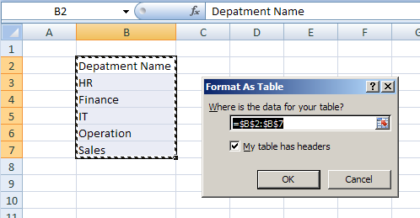

1. Table is created.

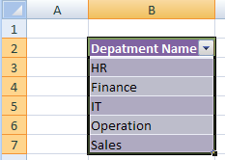

1. To turn off the filter. Unselect the **Filter** option under **Data** tab.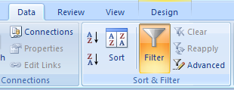

Change Table Name

When the table is created, it is given default name as **Table#**. Where **#** is number starts from 1 onward. But this default name is not meaningful to many applications. Therefore, normally is advisable to change it.

There are various ways to change name

1. Use Name Manager (Refer to next exercise)
2. Select any part of the table, on the **Design** tab, in the **Properties** group:

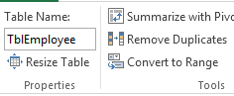

## **EX2.2: *Rename Table***

Continue from previous exercises, in this exercise, you will learn how to rename table

1. Run **Name Manager**. Select the newly created table, press **Edit…**

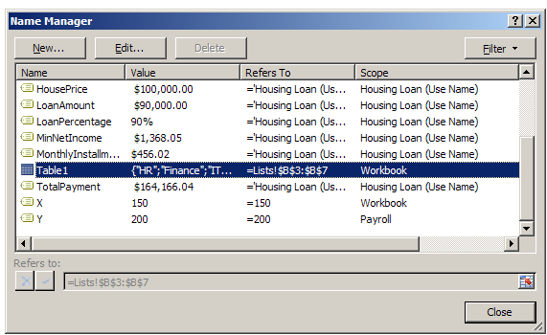

1. Change the name to **TblDepartment**.
2. Take note that only table name can be modified. Table cannot be deleted via Name Manager, and Tables always have workbook scope.

Sorting a Table

1. Right click any table column, select **Sort** and followed by the sort option
2. From Data ribbon tab, **Sort & Filter** group:

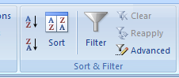

Filtering a Table

1. Right click any table column, select **Filter** and followed by the sort option
2. From **Data** tab, **Sort & Filter** group:



Working with the Total Row

You can use Total Row to apply aggregate function to individual column in the table.

1. Right click table, select **Table** and followed by **Totals Row** option
2. From **Design** tab, **Table Style Options** group:

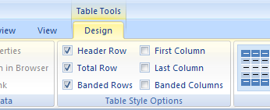

1. Alternatively, you can use right-click option:



Creating a Calculated Column

New table columns can be created. These columns can derive value by referring to other columns in the same table. We call these columns as **Calculated Column**.

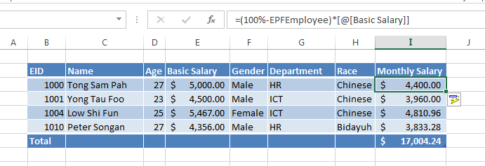

You will experience how to create this kind of columns later in other exercises.

Formatting a Table

Table can apply preset style to save efforts in formatting data. Before create table advisable to clear all formatting of the range. Otherwise, the existing format will disturb the selected style.

To change table style, go to **Home** tab, select style from **Format as Table** under **Styles** group.

The other way is change the style from the **Design** tab, select style under **Table Styles** group.

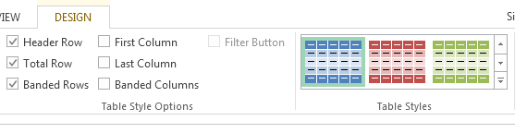

Referring to different parts of table

Once table is created, data from table can be referred in the cell formula.

We can refer to various part of the table:

|  |  |
| --- | --- |
| **Part** | **Example** |
| Table Data | TblEmployee |
| Table Header | TblEmployee[**#Headers**] |
| Table Totals Row | TblEmployee[**#Totals**] |
| Entire Table | TblEmployee[**#All**] |
| Entire Column | TblEmployee[***Gender***] |

## **EX2.3: *Use Table Data in validation (Part-1)***

The parts of table can be considered as range in many cases. Refer to worksheet **Lists**, we created both name **Departments** and table data **TblDepartment**. Both are referring to range B3:B7.

Previously we applied named range (**Departments**)validation of cell G3 under **Employee** worksheet. Since **Departments** and **TblDepartment** both refer to same range, can we substitute **Departments** with **TblDepartment** in the list data validation of cell G3 under **Employee** worksheet?

Let’s give it a try:

1. Switch to worksheet **Employee**.
2. Select **Data** tab, select **Data Validation**.
3. Change the **Source** under **Settings** tab to “=TblDeppartment”, press **OK**.

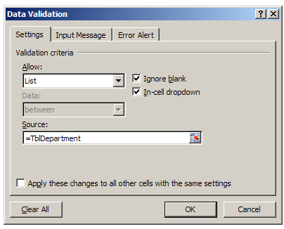

1. You will receive the following error message:

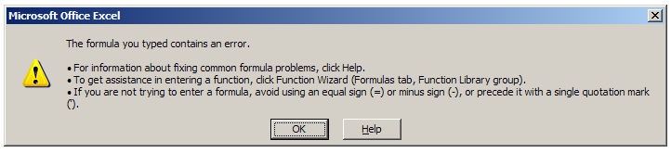

Although named range and table parts can be use interchangeable in many cases, however this case will fail. Table cannot be used **directly** under validation source.

1. Since table data cannot be use directly, we can use **indirectly**. Try change the source to



Beware that the **TblDepartment** must be enclosed in a pair of double quote marks.

**INDIRECT** is one of the complex functions from Excel.

1. Press **OK**. Test it by clicking the dropdown button

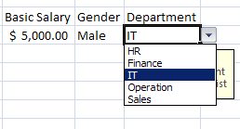

1. Now, delete the **Departments** name from **Name Manager**. Test the validation again.
2. Switch to **Lists** worksheet, select cell B7 (Sales),press **Tab** key, key in **R&D**.

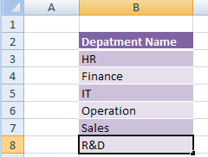

1. Switch back to Employee worksheet, test the validation again.

The advantage of using table data for validation compare to named range is, if the list of data change in future, table data approach does not require to modify the reference from **Name Manager** as needed by the named range approach.

## **EX2.4: *Use Table Data in validation (Part-2)***

The previous approach is adequate when the table only consists of one column. But tables in Excel can consist of multiple columns.

So, what is the impact to the previous approach?

Assuming we need to add more data (columns) to the **TblDepartment** table.

1. Who is the department head?
2. How many employees in the each department?

Let’s try the following steps:

1. Switch to **Lists** worksheet. Select cell C2 and type **Head** then press enter.

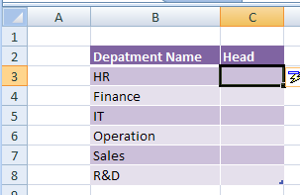

New column is inserted automatically (if cell C3:C8 are empty)

1. Add another column with header **No. of Employees**. Complete the data as below:

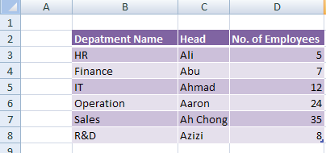

1. Now, switch **Employee** worksheet to the validation again.

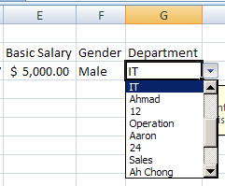

Can you explain why you received the above validation list?

1. Now while selecting cell G3, select **Data** tab, click **Data Validation**.
2. Change the source to **=INDIRECT("TblDepartment[Depatment Name]")**.

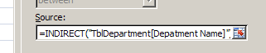

1. Press **OK**. Test the validation again.
2. Discuss why it is a good practice to include column header in the validation rule even for the single column table?

# **Module 3:** *Working with Formatting*

Applying Conditional Formatting

Conditional formatting allows you to automatically apply formatting—such as colors, icons, and data bars—to one or more cells based on the cell value. To do this, you'll need to create a conditional formatting rule.

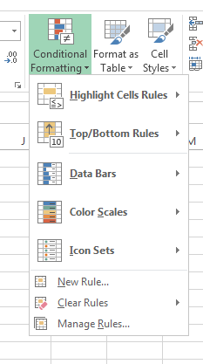

Formatting based on Cells Values

Color code your data will provide special visual effect in analyzing data. You can let Excel show format of your choice when data fulfill certain criteria.

To do this, Select

Home Tab **→** Conditional Formatting**→** New Rule…

Under **New Formatting Rule** dialog box,

1. Select **Format only cell that contain**
2. Select **equal to**
3. Key in the value
4. Press **Format…** button

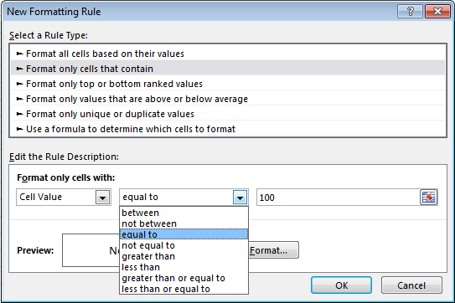

Now you can decide the format that you want.

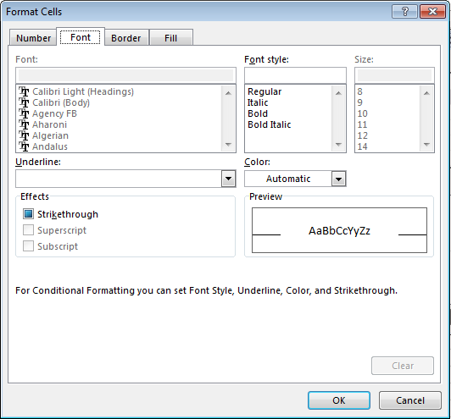

Press **OK** to complete the formatting.

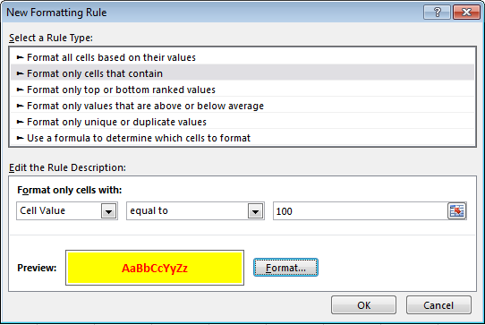

Ensure that the preview format is what you want, press **OK** to End.

Formatting based on Formula

If the conditional options provided are not sufficient to handle some special situations, you can use formula to decide the formatting.

Under **New Formatting Rule** dialog box,

1. Select **Use a formula to determine which cells to format**
2. Key in the formula (The formula must return True or False)
3. Press **Format…** button

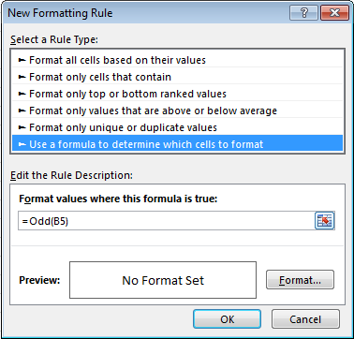

Other Conditional Formatting (bars, scales, icons)

Condition Formatting in Excel also provides some others attractive formatting options such as

**Data Bars**

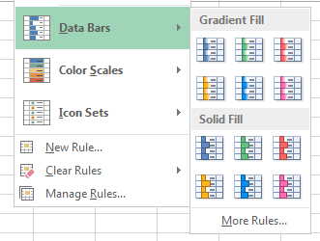

**Color Scales**

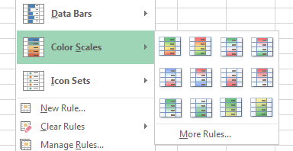

**Icon Sets**

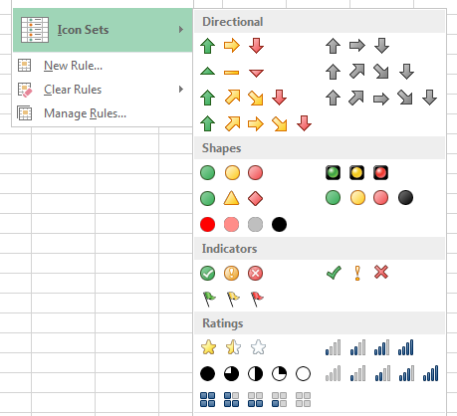

Using Data Validation

It is a good practice to prevent user enter unacceptable data by using Data Validation.

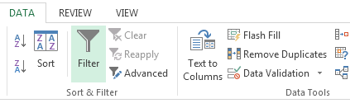

Entry guide

You can provide guide during user enter data.

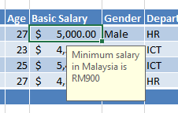

Custom Error Message

Customize error message is important to let user know why they are wrong.

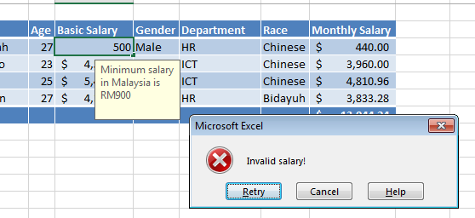

Creating and Using Custom Formats

Besides predefined format, custom formats can be defined for special cases.

1. Right-click on the cell(s)
2. Select **Format Cells…**

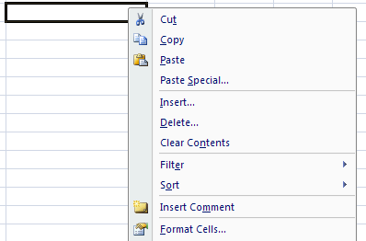

1. In the **Format Cells** dialog box, select **Custom** format

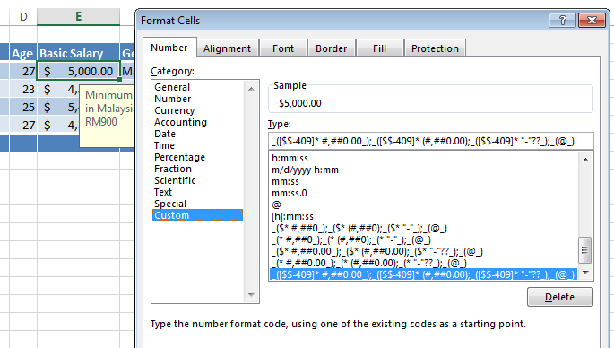

Using the Quick Analysis Tool

You can use the new Quick Analysis Tool in Excel to easy add conditional formatting, charts, totals, and tables to an Excel spreadsheet.

* New feature that lets you access data analysis tools easily
* Microsoft's research showed that many Excel users were simply not aware of the data analysis tools available in Excel
* Many users are reluctant to create charts or tables in Excel because they are worried about being to modify them later
* The Quick Analysis Tool puts data analysis features at your fingertips, as well as options for modifying these elements after you add them to your spreadsheet

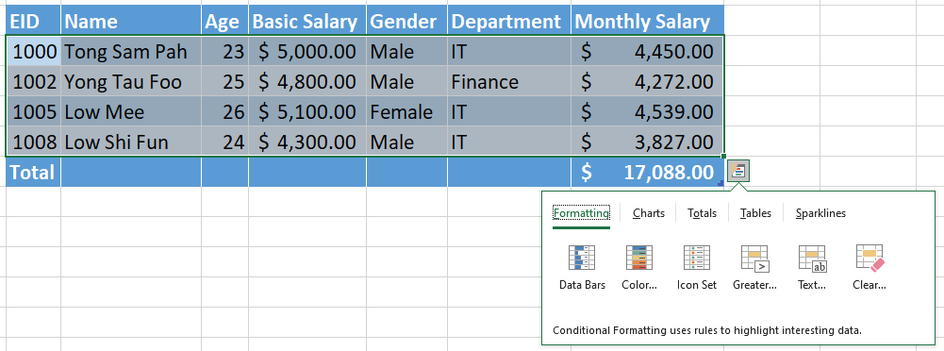

Using Table for Validation

Common practice is to design validation rules for one row in the table. Every new row created later will automatically inherit the same validation.

Something to know about validation

Validation on take effect during user entry. But there are few scenarios validations will not take action. For example:

* Copy and paste
* Value assign by VBA code

## **EX3.1: *Various types of validation***

“Garbage in garbage out” means is data is incorrect, information will be invalid.

During data entry, it is very common data entered wrongly. To prevent invalid data, we can use data validation.

This exercise will provide different data validation alternatives

1. Switch to **Employee**.
2. Cell D3 is about **Age**. Add validation

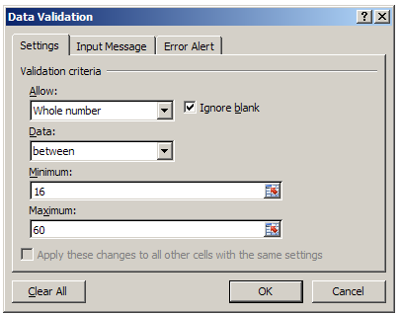

**Input guide:** Valid age to be employee in Malaysia is in between 16 to 60 (inclusive)

**Error Message:** Invalid Employee Age!

1. Cell E3 is about **Basic Salary**. Add validation

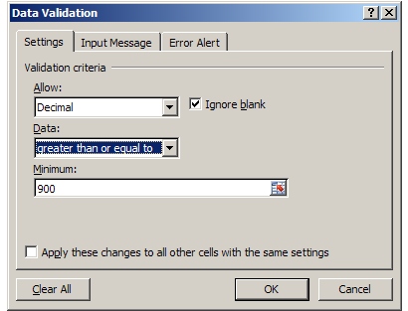

**Input guide:** Minimum salary in Malaysia is $900

**Error Message:** Invalid Basic Salary!

1. Cell F3 is about **Gender**. Add validation

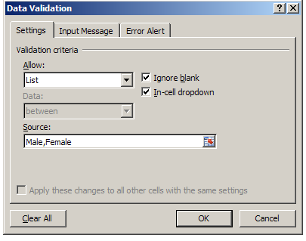

**Input guide:** Select gender from the list.

**Error Message:** Invalid Gender!

## **EX3.2: *Adding calculated column***

In this exercise you will learn how to add calculated column in the table.

1. Highlight cell B2:G3 of **Employee** worksheet.

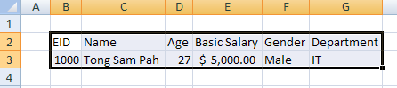

1. Create a new table (with headers). Change the table name as **TblEmployee**.
2. Hide the filter buttons.

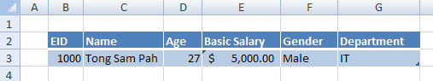

1. Select cell G3, press **Tab** to create a new row.

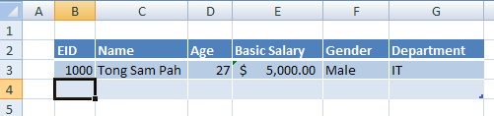

1. Complete the table data below:

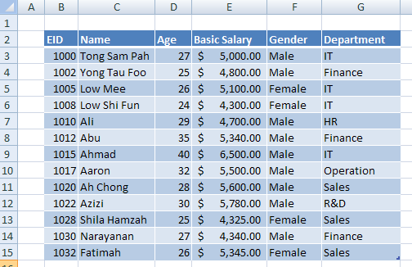

1. Select cell H2, type header **Monthly Salary**. Press **Enter**.
2. Select cell H3, and key the following (but don’t press enter yet)

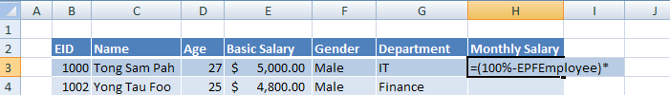

1. While still in the entry, select cell E3. You should get the following:

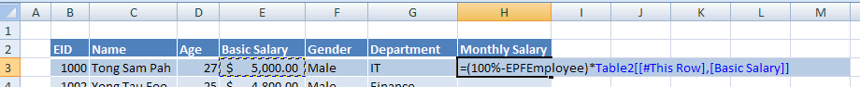

1. Press **Enter** to confirm the formula.

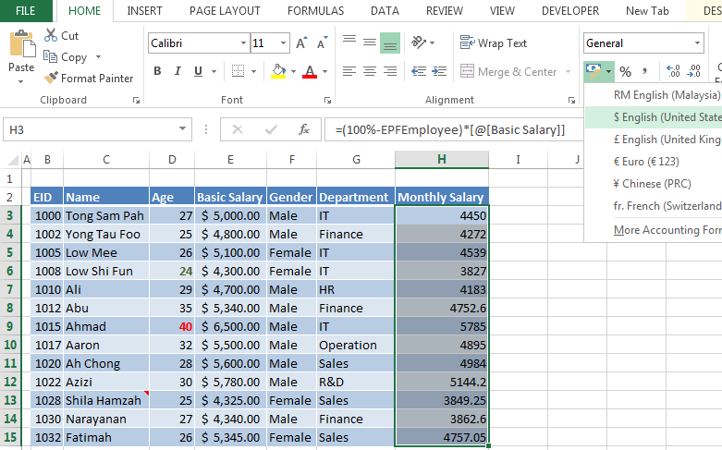

1. Select range H3:H15, Select **Home** tab, select **$** (currency format).

## **EX3.3: *Using Data Bar***

In this exercise you will learn how to use Data Bar Conditional Formatting.

1. Under **Employee** worksheet, select cell I2 then type header **Chart**. Press **Enter**. A new column is created.

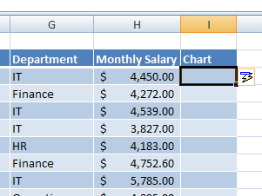

1. While under cell I3, type **=** then select cell H3.

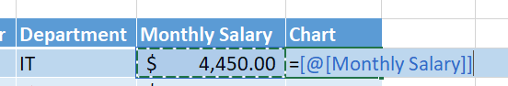

1. Press **Enter**.

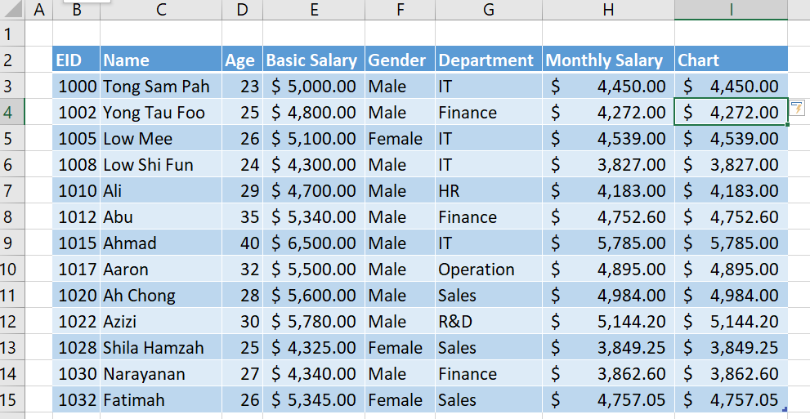

1. Select range I3:I15, select **Home** tab, **Conditional Formatting**, **Data Bars**. And the bar style.

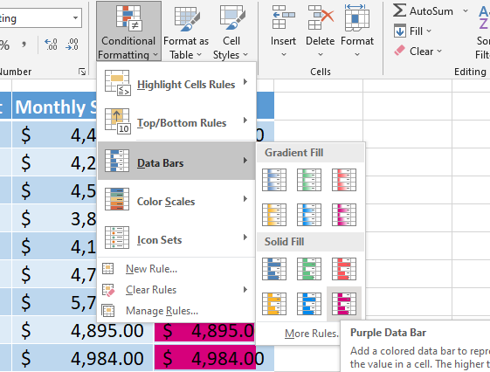

1. While still selecting range I3:I15, select **Conditional Formatting**, **Manage Rules…**

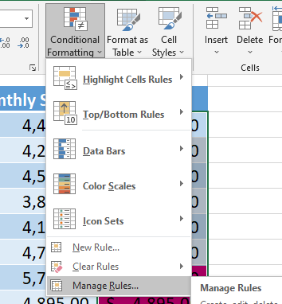

1. In the dialog box, select Data Bar format then click **Edit Rule…**

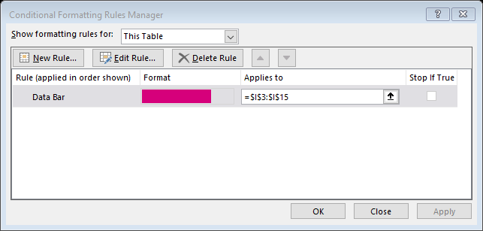

1. In the next dialog box. Check the “Show Bar Only”:

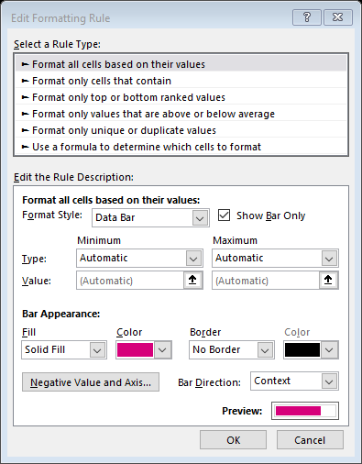

1. Press **OK**. Back to previous dialog box, press **Apply** then **OK** to end the dialog box.
2. Discuss your final result.

## **EX3.4: *Detect Duplicate data***

Imaging your tabular data consists of thousands of row, and some column must have unique value. How can you detect duplicate value entered?

In this exercise you will learn how to detect duplicate values during data entry by using conditional formatting.

1. Switch to **Employee** worksheet.
2. Select range B3:B15 of **TblEmployee**.

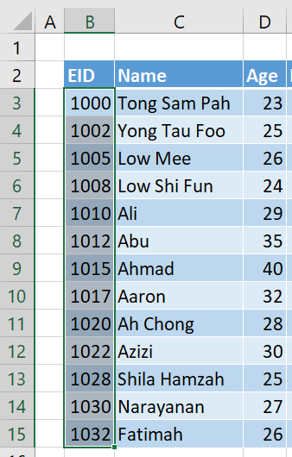

1. Select **Home** tab, **Conditional Formatting**, **New Rules…**

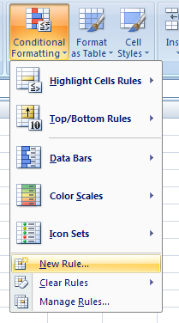

1. In the **New Formatting Rule** dialog box, select **Format only unique or duplicate values** option, click **Format…** button

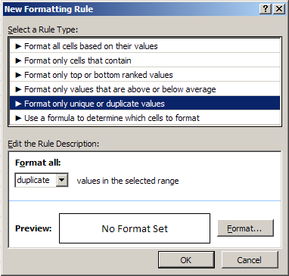

1. In the **Format Cells** dialog box, select **Font** tab, **Font style** click **Bold**, **Color** select **Yellow**.

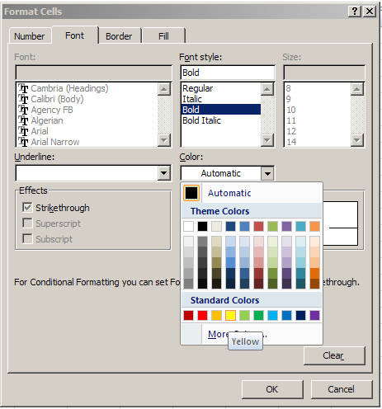

1. While still in the **Format Cells** dialog box, select **Fill**  tab, select **Background Color** as **Red**. Click **OK**.

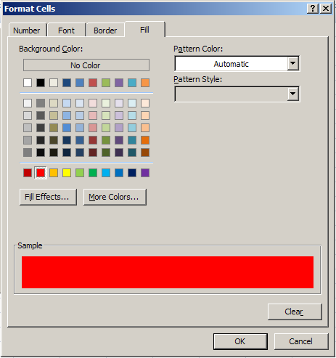

1. Click **OK** again to end the **Format Cells** dialog box.
2. Try to add new row by intentionally key in existing EID.

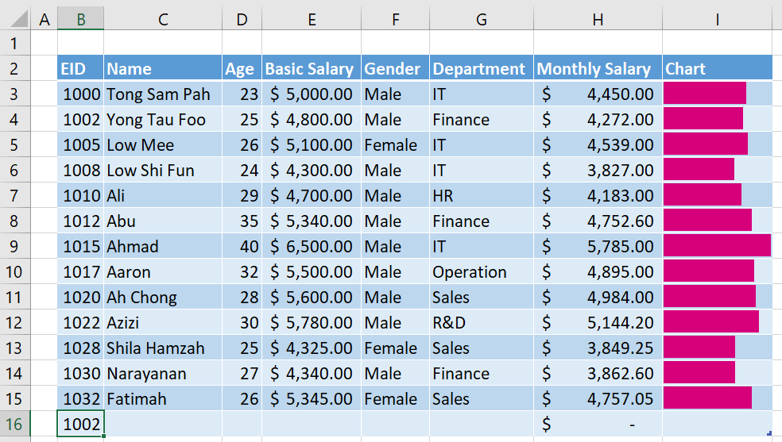

1. Discuss your observation.

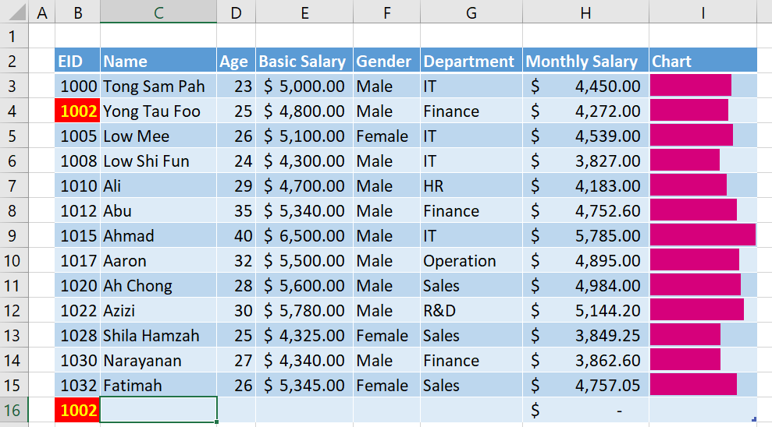

1. Delete the newly created row by right click the new row, then select **Delete**, **Table Rows**.

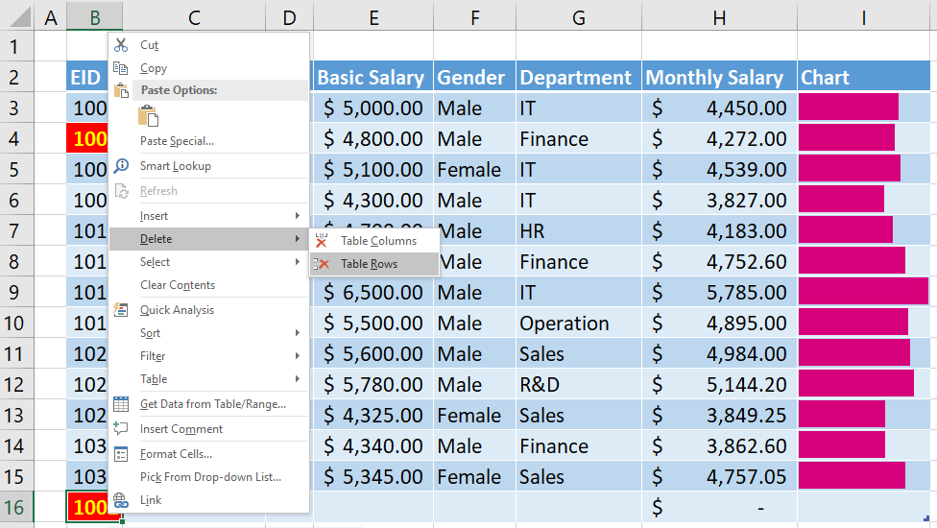

# **Module 4:** *Information Retrieval*

To retrieve valuable information from Excel data you can use

1. Observation Techniques
2. Basic features such as Filter & Sorting
3. Functions and Formulas
4. Advanced Features such as Pivot Tables and Power-4
5. Programming such as VBA

In this intermediate training, we will not cover Power-4 and Programming.

Observation Techniques

By leveraging on the Conditional formatting (in Module-3) and Charting (in Module-5), we can visualize the information without extra effort.

Basic Features – Filter and Sorting

Excel provides some basic features to allow users focusing on certain aspects of information and allow reorder the data in the sequence to ease information retrieval.

Filtering is the basic feature to hide unnecessary data so that users can derive valuable information.

Sorting is the basic feature to rearrange data sequence to help users to derive information from it.

Using Functions and Formulas

The above-mentioned basic features require users to manually retrieve information. If, the information acquired is needed to be an input to another part of the model, this manual process will allow room to make mistake.

To solve this problem, Excel provides functions and formula to retrieve information and link them to other part of model.

The complete set of functions you can refer to Microsoft official site:

<https://support.microsoft.com/en-us/office/formulas-and-functions-294d9486-b332-48ed-b489-abe7d0f9eda9?ui=en-US&rs=en-US&ad=US#id0eaabaaa=functions>

Using Pivot Table

PivotTable is one of the unique powerful features provided by Excel. It is one of the main reasons so many users decided to use Excel instead of other tools in data analysis.

With Pivot Table, user can find useful information from different perspectives of data. It allows users to extract the significance from a large, detailed data set.

## ***EX4.1: VLookup (Exact Match)***

In this exercise you will learn how to use VLookup exact match to retrieve data from another table.

Consider the case where company need to know the KPI of each employee. A new table will be created.

1. Create a new worksheet with name **KPI**.
2. Prepare the following table

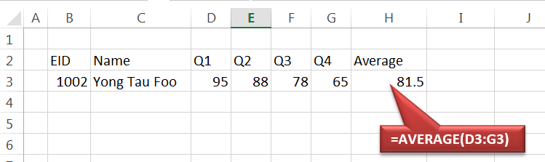

1. Discuss what are the issues if the user needs to key in employee name?
2. Prepare a column formula for cell C3

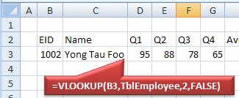

1. Add data validation to cell B3

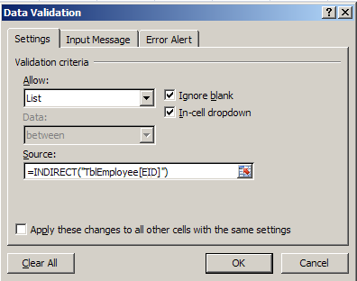

1. Try to select different EID

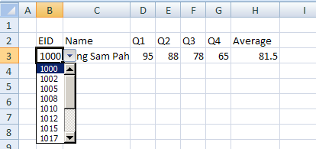

1. Discuss your observation
2. Try to delete cell B3’s value. Discuss your observation
3. Convert the tabular data to table and name it as **TblKPI**.

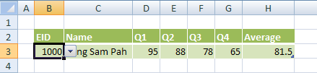

1. Try to add few new records, identify any problem occurs and suggest solution.
2. How to highlight duplicate EID selection?

## **EX4.2: *VLookup (Approximate Match)***

From the previous created table **TblKPI**, the management needs to make decision about the average performance of each employee based on the table below:

|  |  |
| --- | --- |
| **Average Performance** | **Action** |
| Below 40% | Warning Letter |
| 40% to less than 70% | (No Action) |
| 70% to less than 80% | Increase Salary |
| 80% to less than 90% | Promotion |
| 90% onward | Increase Salary + Promotion |

A new column with header **Action** will be added to TblKPI. The value of this column will be derived from column **Average** and the abovementioned table.

1. Create a new table with name **TblAction** under worksheet **Lists**.

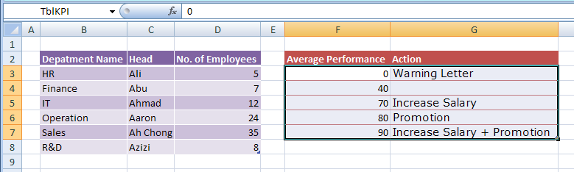

1. Switch to worksheet **KPI**. Prepare the data in the **TblKPI** table.

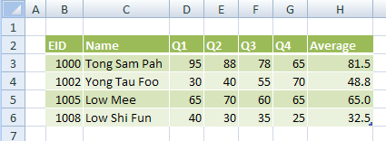

1. Add new column **Action** to table **TblKPI** under worksheet **KPI**.

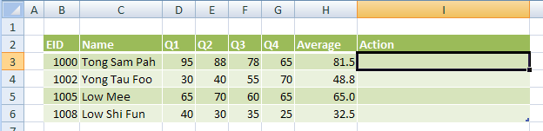

1. Add column formula to column **Action** of table **TblKPI**.

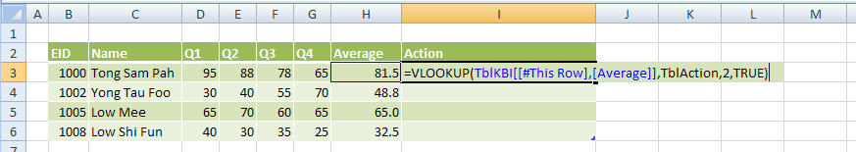

This part of formula will be added by just click on cell **H3**

1. Discuss your observation.
2. Select cell I6, press **TAB** key to generate new row.

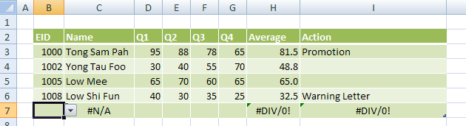

Beware that we still have these few problems.

Fix Your VLookup Error

Sometime we want to silent about unsuccessful lookup or error generated from calling the VLookup function. In Excel 2007 you can use the following approaches:

1. Check the data before calling VLookup
2. Let the VLookup generate error and substitute the error with something else.

## **EX4.3: *Create PivotTable***

In this exercise, you will learn how to create PivotTable to analysis data from **Employee** table.

1. Select **TblEmployee** from Excel **Name Box**.

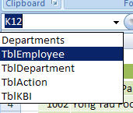

1. This will bring you to the **TblEmployee** table. While the table is selected, select **Insert tab**. Select **PivotTable** button.

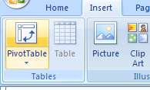

1. In the **Create PivotTable** dialog box, just press **OK** button.

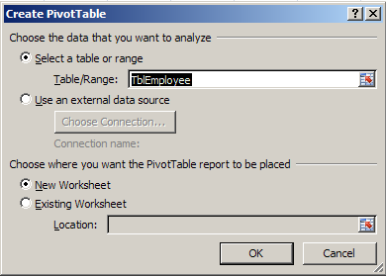

1. A new PivotTable is created in new worksheet.

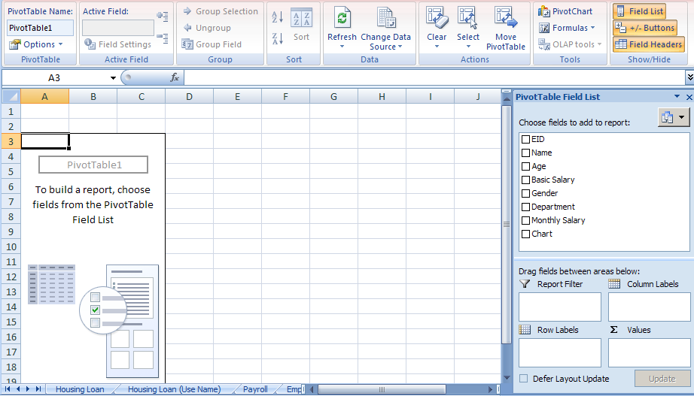

## **EX4.4: *View fields and data***

In this exercise, you will learn how to view field and data from a PivotTable.

1. From the previously created PivotTable
   1. Drag the **Department** field to **Report Filter**.
   2. Drag the **Gender** field to **Row Labels**.
   3. Drag the **Gender** field again to **Value**.

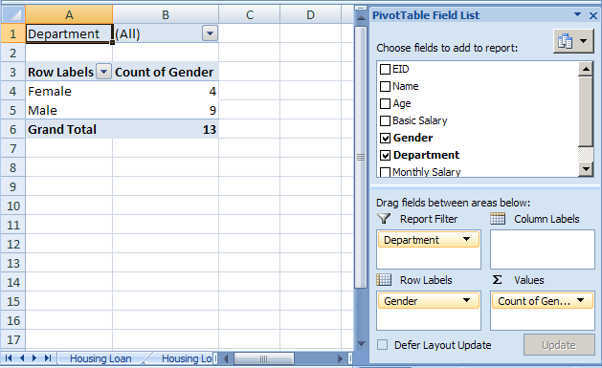

What kind of information the PivotTable showing now?

1. Try to select **Filter** button under **Report Filter**. Just select **IT** then press **OK**.

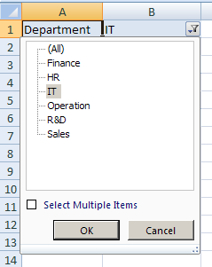

What kind of information the PivotTable showing now?

1. Now Drag the **Department** field from **Report Filter** to **Column Labels**. Observe the result produced.

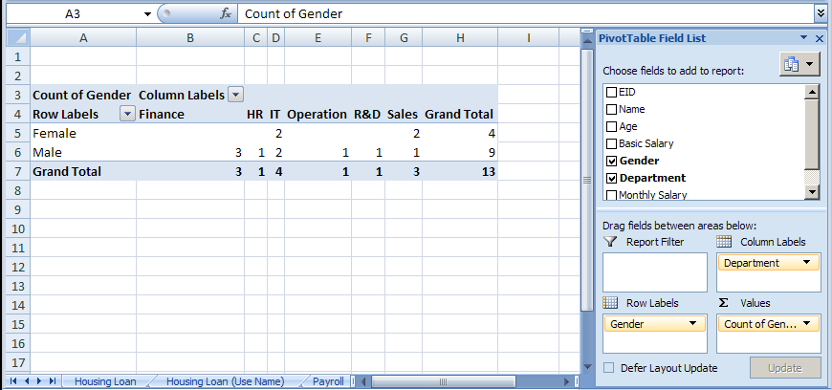

1. Try to play around with the PivotTable to find out the following information:
   1. Number of employees for each department
   2. Average employee Monthly Salary for each department
   3. Average Salary for different gender

Give your PivotTable a name

When PivotTable is created, Excel will assign a default name to it. If you want to rename it, there are many possible ways. One of the simplest ways is

1. Select **Options** tab
2. Change the name from the **PivotTable Name** field

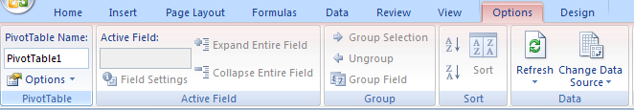

Change field settings

When fields are dragged to the areas, Excel will provide default setting for the fields. Sometime the customization of the field is needed.

To change the field setting, just click on the **dropdown arrow** for each field:

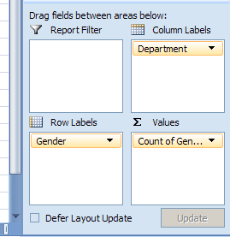

You should be able to find the **Field Settings…**

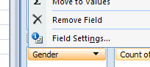

Styles

To change the PivotTable style,

1. Select **Design** tab

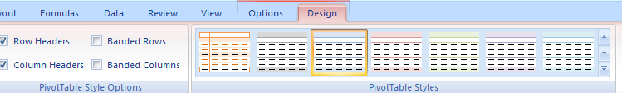

1. You can select any desire style
2. More style will be listed if you select the dropdown button.

## ***EX4.5: Filter a field***

In this exercise, you will learn how to filter a field to hide unwanted candidates.

1. From the previous PivotTable, select **Column Labels** dropdown button.

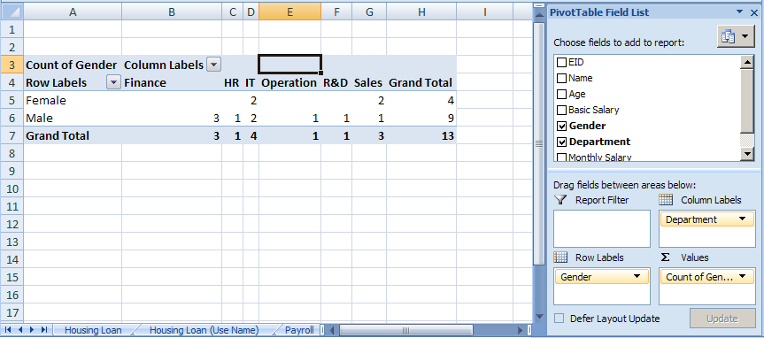

1. Just select **IT**, **Operation**, and **R&D**. Press **OK**.

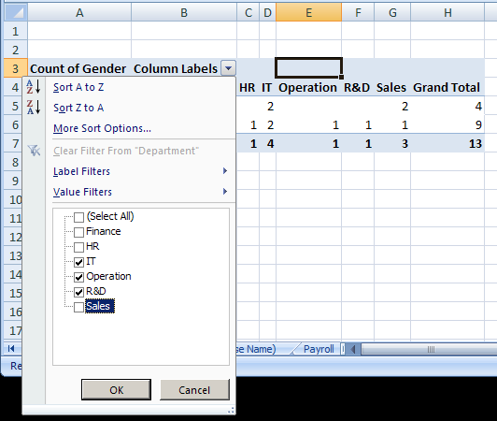

1. Observe the result.

## **EX4.6: *Create PivotChart***

A pivot chart is the visual representation of a pivot table in Excel. Pivot charts and pivot tables are connected with each other. In this exercise, you will learn how to create PivotChart.

1. Select **TblEmployee** from Excel **Name Box**.



1. This will bring you to the **TblEmployee** table. While the table is selected, select **Insert tab**. Select **PivotTable** dropdown button, then select **PivotChart**.

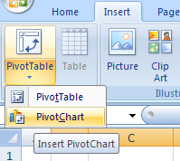

1. In the **Create PivotTable with PivotChart** dialog box, just press **OK**.

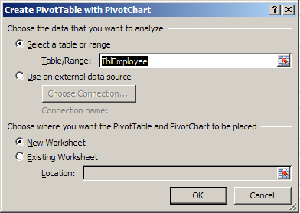

1. Try to drag around with the PivotTable to find out the following information:
   1. Drag the **Department** field to **Row Labels**.
   2. Drag the **Gender** field to **Report Filter**.
   3. Drag the **Gender** field again to **Value**.
2. Try to change other setting to make the final result looks like the following:

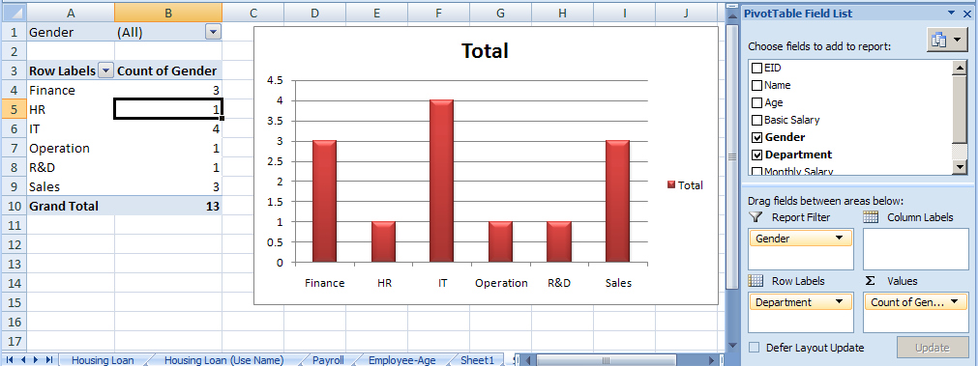

# **Module 5:** *Working with Charts*

Creating Charts

When presenting information, picture normally is better than thousands words. Charting allows use visualize our data/information graphically.

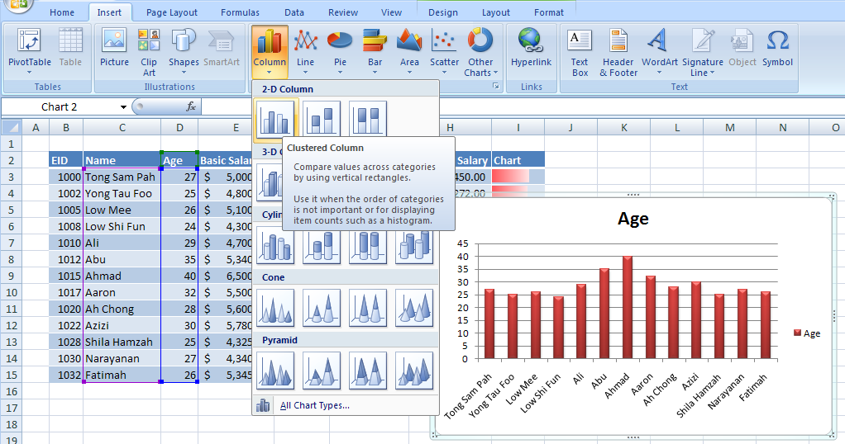

## **5.1: *Add Chart***

In this exercise, you will learn how to add column chart in to worksheet.

1. Switch to **Employee** worksheet. Select columns **Name** and **Age** from table **TblEmployee**.

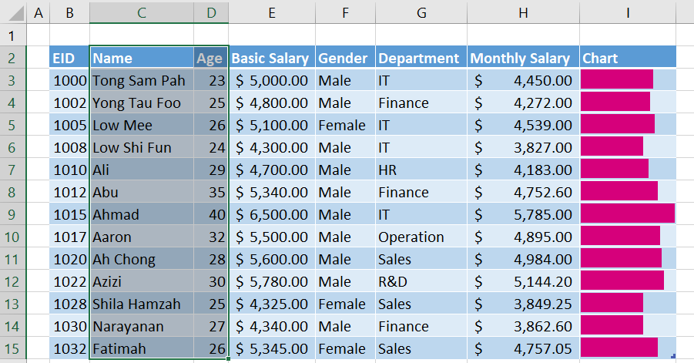

1. Select **Insert** tab. **Column** button. Under **2-D Column,** select first chart (Clustered Column) type.

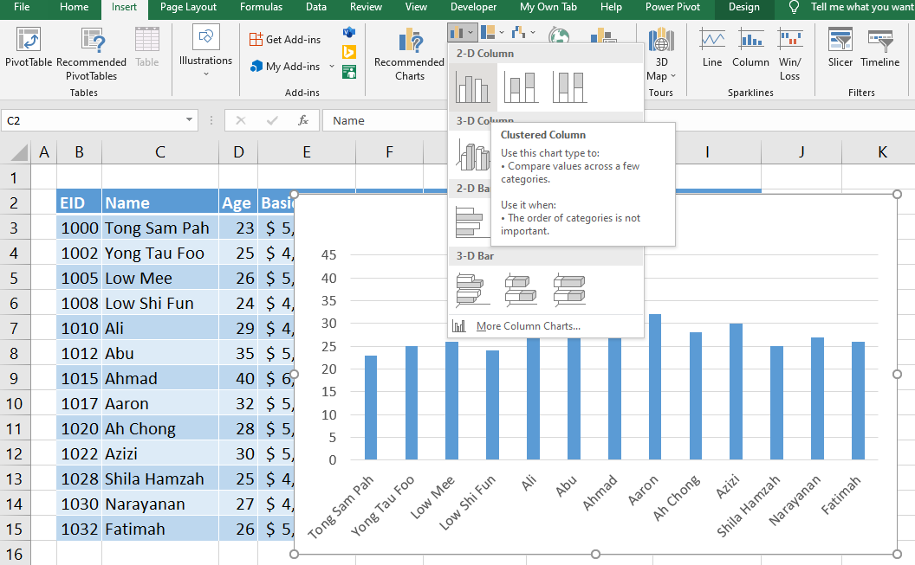

1. New clustered column chart is created as below:

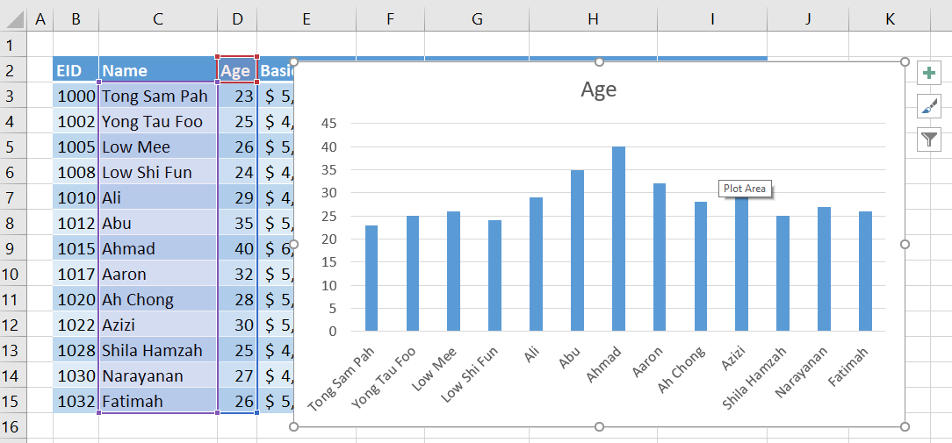

1. While the chart is selected, select the **More** dropdown button under **Design** tab.

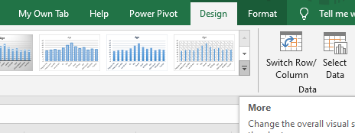

1. Select the any design.

Changing the Chart Location and Size

You can easily move and resize chart simply by using mouse.

Chart also can be moved to other sheet.

## ***5.2: Move Chart***

In this exercise, you will learn how to move chart to new chart sheet.

1. Right click the previously created chart, select **Move Chart…**

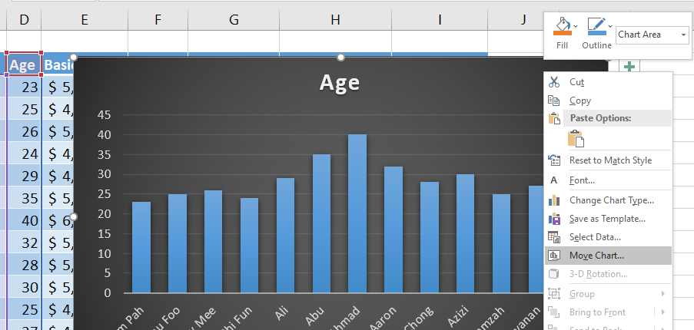

1. In the **Move Chart** dialog box,type **Employee-Age** under **New sheet** field. Click **OK**.

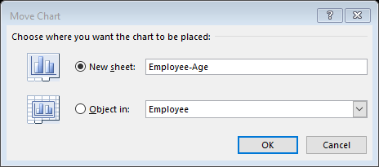

1. A new chart sheet is created

Changing the Chart Type

To change chart type, just right click on the chart then select **Change Chart Type…**

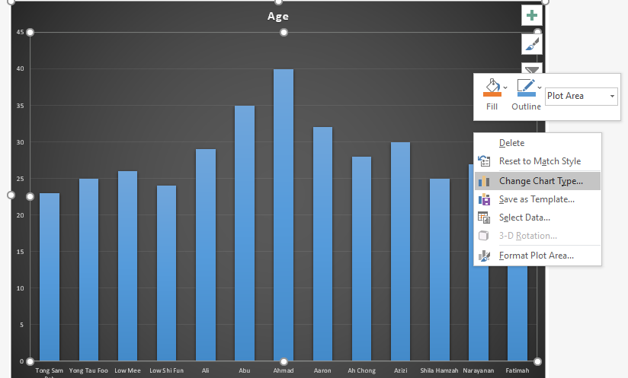

Modifying Chart Elements

You can select the chart elements and format them separately. Example:

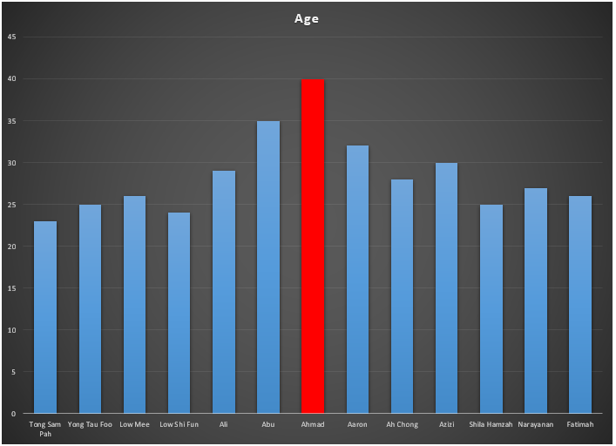

Formatting Chart Elements

The appearance of the chart element can be change independently by select and right click, then change from the floating menu.

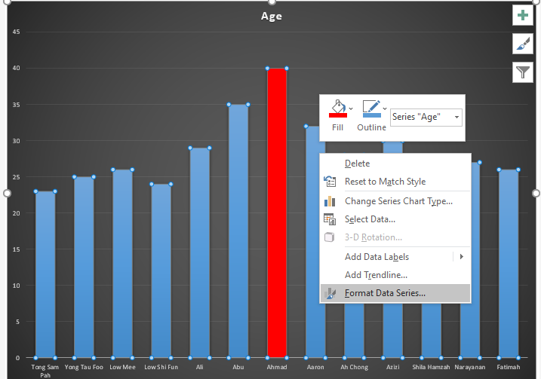

Adding and Removing Data Series

Charts may have multiple data series.

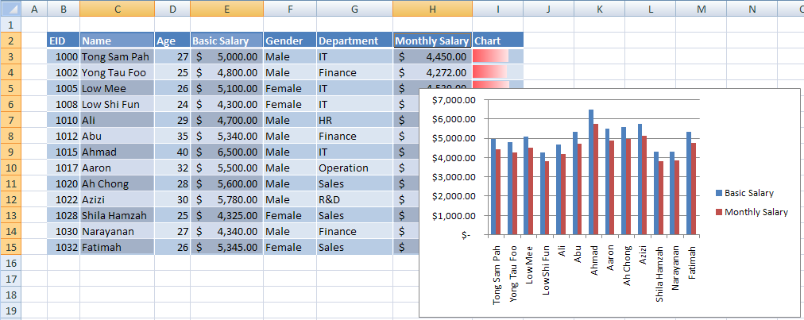

## ***EX5.3: Create multiple Data Series chart***

In this exercise, you will learn how to create multiple data series chart.

1. Switch to **Employee** worksheet. Select Columns (Inclusive headers) **Name, Basic Salary** and **Monthly Salary**.

**Hint:** use control-select to select disjointed range.

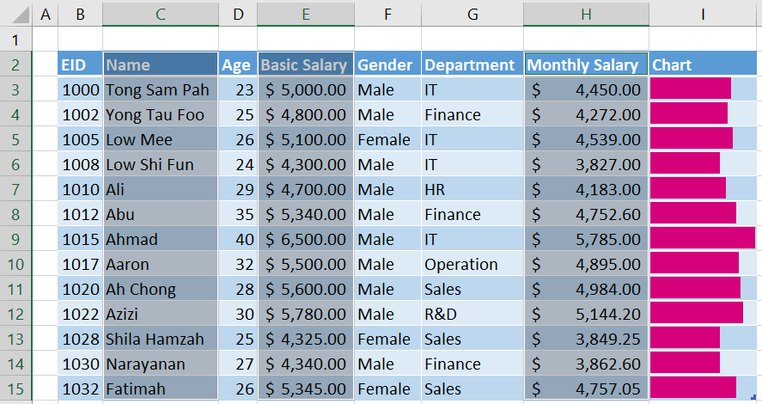

1. Select **Insert** tab, **Recommended Charts** button under **Charts** group, click **Clustered Column** chart type.

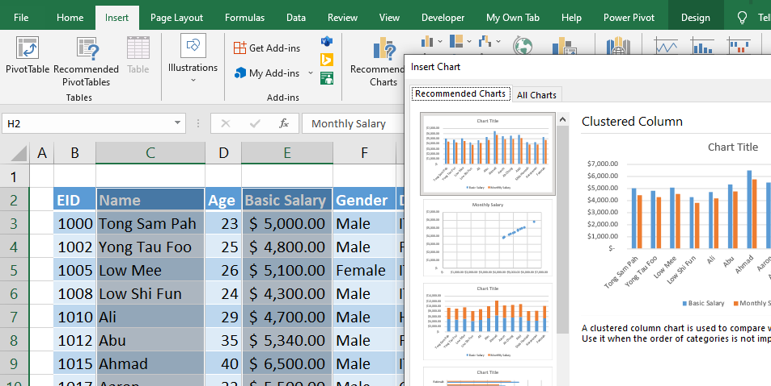

1. New multiple data series chart is created.

## **EX5.4: *Remove Data Series***

In this exercise, you will learn how to remove data series from chart.

1. Right click on the previously created multiple data series column chart. Click **Select Data…** option.

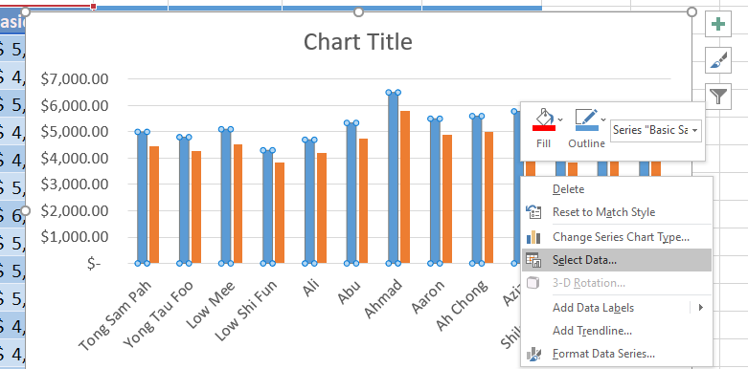

1. In **Select Data Source** dialog box, select **Monthly Salary** under **Legend Entries (Series)** then click **Remove** button. Click **OK** to end the dialog box

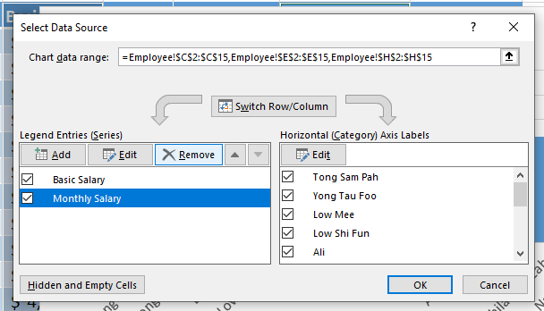

1. Now the chart change to

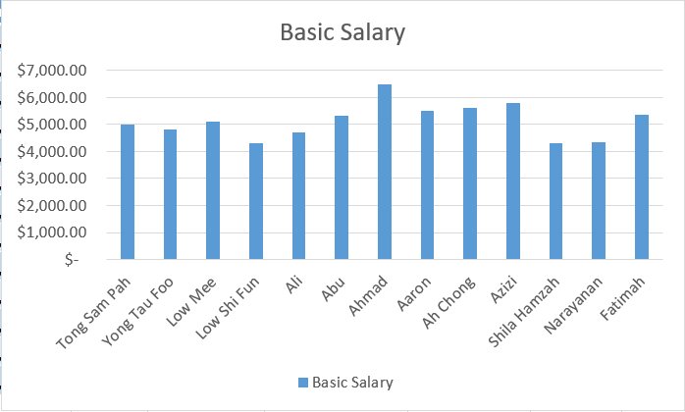

Applying a Chart Filter

Chart Filter allow users to exclude subset of data from the chart.

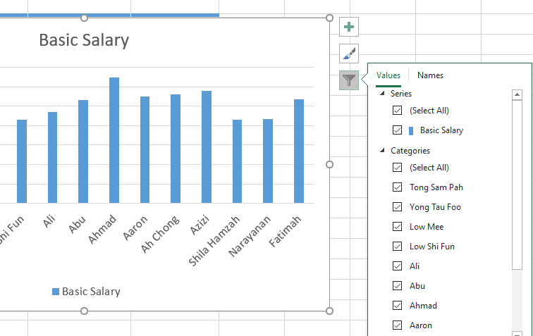

Printing Charts

To print chart, common practice is

1. First of all, move the chart to separate chart sheet.
2. Make sure that the chart sheet is active sheet
3. Click **File** menu, select **Print** menu item, the **Print** option
4. In the **Print** dialog box, select the printer in used and configure printer properties. Ensure that **Active sheet(s)** is selected then click **OK** to start printing.

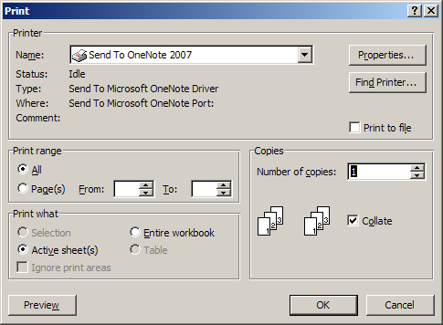

Creating and Using a Chart Template

After you created a chart with the format or style that you like, you can then save it as chart template. Just right-click the chart, select “Save as Template”.

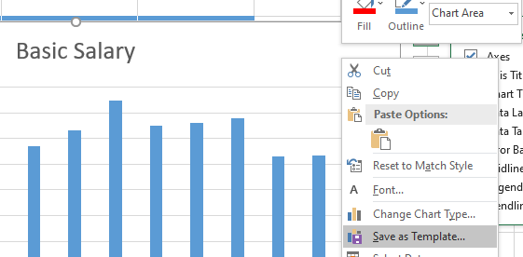

In the future you can apply the chart template to other chart with the same type. With this you are not only save time, consistency of look and feel for the charts with the same type are preserved.

## **EX5.5: *Sparkline***

Sparklines in Excel are graphs that fit in one cell. Sparklines are great for displaying trends.

In this exercise, you will learn how to use Sparklines.

1. Refer to the previously created TblKPI:

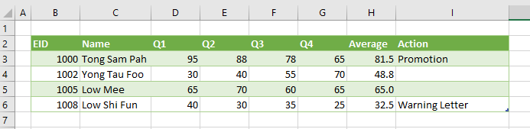

1. Add a new column “Trend” after Action column:

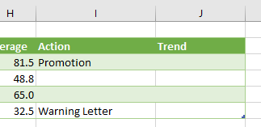

1. Select the first cell just under the Trend title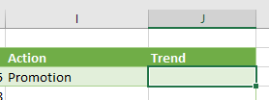:
2. Go to Insert ribbon tab. Select line sparkline:

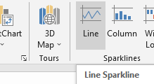

1. In Create Sparklines dialog box, select value Q1 to Q4 on the same row, the press **OK**:

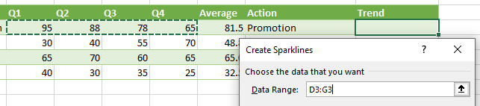

1. A Sparkline is created in the selected cell:

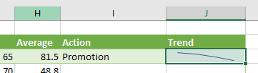

1. While the newly created sparkline still selected, check the Markers from the Design ribbon tab:

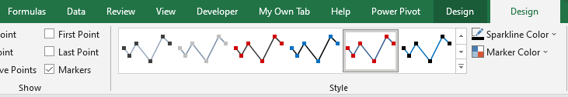

1. Drag the auto-fill handle until the end of table:

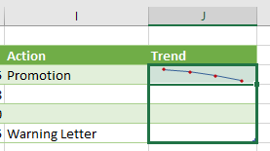

1. What is your conclusion to Mr Yong’s performance?

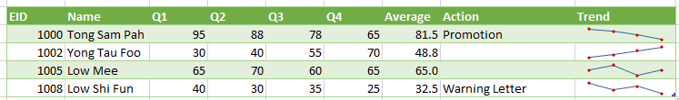

# **Module 6:** *Protection*

Protecting Workbooks and Worksheets

To prevent other users from viewing hidden worksheets, adding, moving, deleting, or hiding worksheets, and renaming worksheets, you can protect the structure of your Excel workbook with a password.

**Notes:** Protecting the workbook is not the same as protecting an Excel file or a worksheet with a password.

## **EX6.1: *Protect the workbook structure***

To protect the structure of your workbook, follow these steps:

1. Click **Review** > **Protect Workbook**.

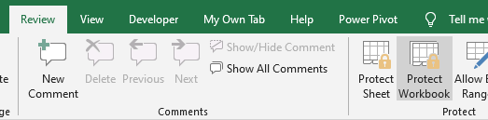

**Note:** The **Windows** option is available only in Excel 2007, Excel 2010, Excel for Mac 2011, and Excel 2016 for Mac. Select the **Windows** option if you want to prevent users from moving, resizing, or closing the workbook window, or hide/unhide windows.

1. Enter a password in the **Password** box.

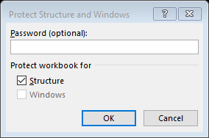

**Important:** The password is optional. If you do not supply a password, any user can unprotect and change the workbook. If you do enter a password, make sure that you choose a password that is easy to remember. Write your passwords down and store them someplace safe. If you lose them, Excel cannot recover them for you.

1. Select **OK**, re-enter the password to confirm it, and then select OK again.

## **EX6.2: *Protecting a Workbook***

To prevent others from accessing data in your Excel files, protect your Excel file with a password.

1. Select **File > Info.**

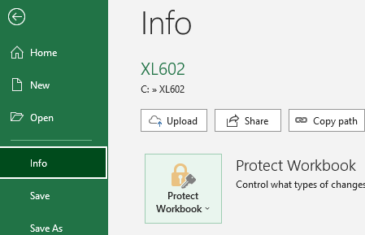

1. Select the **Protect Workbook** box and choose **Encrypt with Password**.

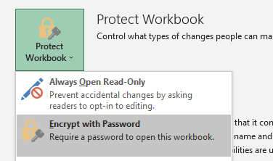

1. Enter a password in the **Password** box, and then select **OK**.
2. Confirm the password in the **Reenter Password** box, and then select **OK**.

**Warning:**

* Microsoft cannot retrieve forgotten passwords, so be sure that your password is especially memorable.
* There are no restrictions on the passwords you use with regards to length, characters or numbers, but passwords are case-sensitive.
* It’s not always secure to distribute password-protected files that contain sensitive information such as credit card numbers.
* Be cautious when sharing files or passwords with other users. You still run the risk of passwords them falling into the hands of unintended users. Remember that locking a file with a password does not necessarily protect your file from malicious intent.

## **EX6.3: *Protecting a Worksheet***

To prevent other users from accidentally or deliberately changing, moving, or deleting data in a worksheet, you can lock the cells on your Excel worksheet and then protect the sheet with a password. Say you own the team status report worksheet, where you want team members to add data in specific cells only and not be able to modify anything else. With worksheet protection, you can make only certain parts of the sheet editable and users will not be able to modify data in any other region in the sheet.

Choose what cell elements to lock

Here's what you can lock in an unprotected sheet:

* [**Formulas**](https://support.microsoft.com/en-us/office/display-or-hide-formulas-f7f5ab4e-bf24-4efc-8fc9-0c1b77a5356f)**:** If you don’t want other users to see your formulas, you can hide them from being seen in cells or the Formula bar
* [**Ranges**](https://support.microsoft.com/en-us/office/lock-or-unlock-specific-areas-of-a-protected-worksheet-75481b72-db8a-4267-8c43-042a5f2cd93a)**:** You can enable users to work in specific ranges within a protected sheet

## **EX6.4: *Allowing Users to Edit Ranges***

Worksheet protection is a two-step process: the first step is to unlock cells that others can edit, and then you can protect the worksheet with or without a password.

Step 1: Unlock any cells that needs to be editable

1. In your Excel file, select the worksheet tab that you want to protect.
2. Select the cells that others can edit.

**Tip:** You can select multiple, non-contiguous cells by pressing Ctrl+Left-Click.

1. Right-click anywhere in the sheet and select **Format Cells** (or use **Ctrl+1**, or **Command+1** on the Mac), and then go to the **Protection** tab and clear **Locked**.

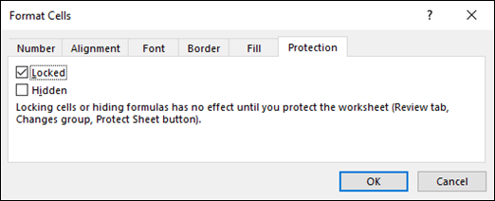

Step 2: Protect the worksheet

Next, select the actions that users should be allowed to take on the sheet, such as insert or delete columns or rows, edit objects, sort, or use AutoFilter, to name a few. Additionally, you can also specify a password to lock your worksheet. A password prevents other people from removing the worksheet protection—it needs to be entered to unprotect the sheet.

Given below are the steps to protect your sheet.

1. On the **Review** tab, click **Protect Sheet**.

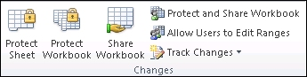

1. In the Allow all users of this worksheet to list, select the elements you want people to be able to change.

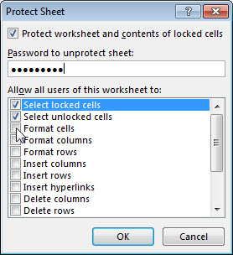

1. Optionally, enter a password in the **Password to unprotect sheet** box and click **OK**. Reenter the password in the **Confirm Password** dialog box and click **OK**.

**Important:**

* Use strong passwords that combine uppercase and lowercase letters, numbers, and symbols. Weak passwords don't mix these elements. Passwords should be 8 or more characters in length. A passphrase that uses 14 or more characters is better.
* It is critical that you remember your password. **If you forget your password, Microsoft cannot retrieve it.**

# **Module 7:** *Using Styles and Templates*

Working with Cell Styles

To apply several formats in one step, and to make sure that cells have consistent formatting, you can use a cell style. A cell style is a defined set of formatting characteristics, such as fonts and font sizes, number formats, cell borders, and cell shading. To prevent anyone from making changes to specific cells, you can also use a cell style that locks cells.

## **EX7.1: *Apply a cell style***

1. Select the cells that you want to format.
2. On the **Home** tab, in the **Styles** group, click the **More** dropdown arrow in the style gallery, and select the cell style that you want to apply.

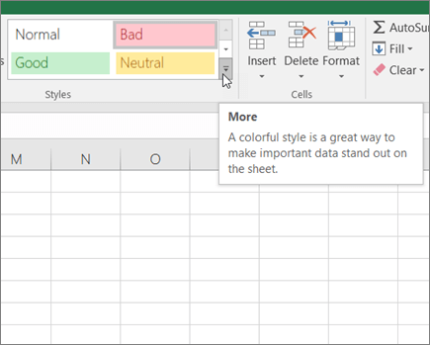

## **EX7.2: *Create a custom cell style***

1. On the **Home** tab, in the **Styles** group, click the **More** dropdown arrow in the style gallery, and at the bottom of the gallery, click **New Cell Style**.

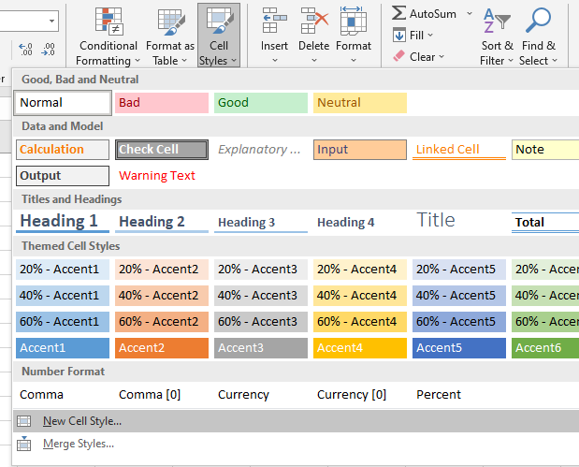

1. In the **Style name** box, type an appropriate name for the new cell style.
2. Click **Format**.
3. On the various tabs in the **Format Cells** dialog box, select the formatting that you want, and then click **OK**.
4. Back in the **Style** dialog box, under **Style Includes (By Example)**, clear the check boxes for any formatting that you do not want to include in the cell style.
5. Click **OK**.

## **EX7.3: *Create a cell style by modifying an existing cell style***

1. On the **Home** tab, in the **Styles** group, click the **More** dropdown arrow in the style gallery.



1. Do one of the following:

* To modify an existing cell style, right-click that cell style, and then click **Modify**.
* To create a duplicate of an existing cell style, right-click that cell style, and then click **Duplicate**.

1. In the **Style name** box, type an appropriate name for the new cell style.

**Note:** A duplicate cell style and a renamed cell style are added to the list of custom cell styles. If you do not rename a built-in cell style, the built-in cell style will be updated with any changes that you make.

1. To modify the cell style, click **Format**.
2. On the various tabs in the **Format Cells** dialog box, select the formatting that you want, and then click **OK**.
3. In the **Style** dialog box, under **Style Includes**, select or clear the check boxes for any formatting that you do or do not want to include in the cell style.

## **EX7.4: *Remove a cell style from data***

You can remove a cell style from data in selected cells without deleting the cell style.

1. Select the cells that are formatted with the cell style that you want to remove.
2. On the **Home** tab, in the **Styles** group, click the **More** dropdown arrow in the style gallery.



1. Under **Good, Bad, and Neutral**, click **Normal**.

## **EX7.5: *Merging Style***

You can merge style from other open workbooks.

1. On the **Home** tab, in the **Styles** group, click the **More** dropdown arrow in the style gallery, and at the bottom of the gallery, click **Merge Style**.

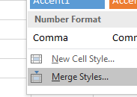

1. In the Merge Styles dialog box, choose open workbooks to merge style from.

## **EX7.6: *Delete a predefined or custom cell style***

You can delete a predefined or custom cell style to remove it from the list of available cell styles. When you delete a cell style, it is also removed from all cells that are formatted with it.

1. On the **Home** tab, in the **Styles** group, click the **More** dropdown arrow in the style gallery.



1. To delete a predefined or custom cell style and remove it from all cells that are formatted with it, right-click the cell style, and then click **Delete**.

Using Templates

If you often use the same layout or data in a workbook, save it as a template so you can use the template to create more workbooks instead of starting from scratch.

You can use one of your own templates to create a new workbook, or you can use one of the many predefined templates that you can download from Microsoft Office Online.

## **EX7.7: *Save a workbook as a template***

1. If you’re saving a workbook to a template for the first time, start by setting the default personal templates location:
   1. Click **File** > **Options**.
   2. Click **Save**, and then under **Save workbooks**, enter the path to the personal templates location in the **Default personal templates location** box.

This path is typically: C:\Users\[UserName]\Documents\Custom Office Templates

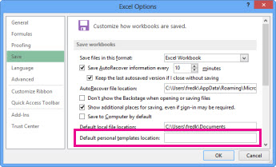

* 1. Click **OK**.

1. Open the workbook you want to use as a template.
2. Click **File** > **Export**.
3. Under **Export**, click **Change File Type**.
4. In the **Workbook File Types** box, double-click **Template**.
5. In the **File name** box, type the name you want to use for the template.
6. Click **Save**, and then close the template.

## **EX7.8: *Create a workbook based on the template***

With the template you created above, you can create a new workbook. This section tells you how to do that.

**Note:** Alternately, you can browse for various online templates in Excel and use them instead.

1. Click **File** > **New**.
2. Click **Personal**.

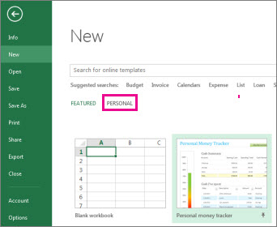

1. Double-click the template you just created.

Excel creates a new workbook that is based on your template.